Statement of Delivery

# Changes

## Content Structure

The number of pages has been scaled back so that the user isn’t overwhelmed by information. The new site map is shown in Figure 1 Sitemap. In this image the blue and Black pages indicate those which are accessible globally.

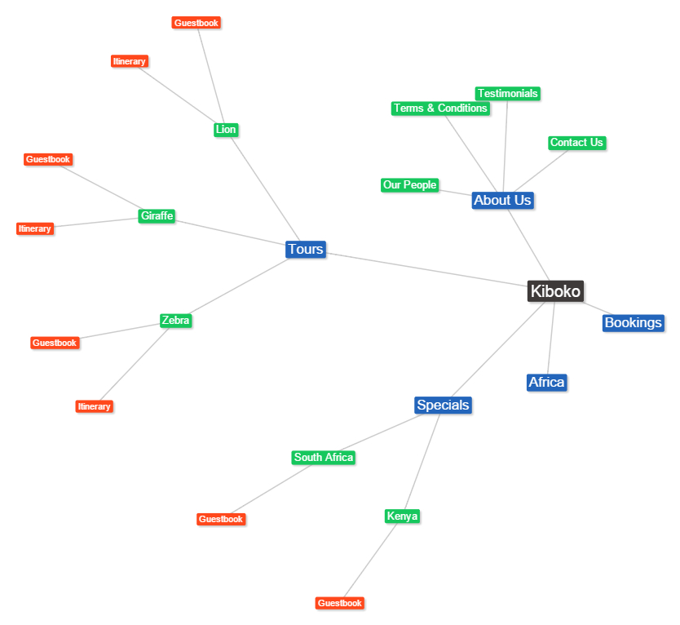

Figure Sitemap

## Visual Design

### Colour Scheme



The colour scheme has been modified slightly in order to improve contrast. The brown is still used for background and has a hex code of 381f16, the green is used for headings and is 679a00, the grey is used for the background and has a value of e0e0e0 and the yellow and orange are used as accents and are valued at e8bc00 and ff9335. To assist in ensuring the text has enough contrast background corresponding to the colour scheme will sometimes be used.

# Javascript

## Slideshow

This is situated on the homepage and cycles through a variety of images showing users some of the experiences they can participate in through Kiboko.

## Form Validation

This is used on the contact us page to ensure that the user has filled out the form correctly. This uses both jquery and

# References

Retrieved 21 May 2015, from https://marhabaqatar.wordpress.com/2013/08/21/four-additional-flights-per-week-to-nairobi-kenya/

Africa, U. (2015). *Ultimate Africa*. *G Adventures*. Retrieved 21 May 2015, from https://www.gadventures.com/trips/ultimate-africa/DAUA/2015

Canopytour.co.za,. (2015). *Tsitsikamma Canopy Tour® | Canopy Tours South Africa*. Retrieved 21 May 2015, from http://www.canopytour.co.za/locations/tsitsikamma

Else, D. (2004). *Africa on a shoestring*. Footscray, Vic.: Lonely Planet Publications.

Expertafrica.com,. (2015). *Expert report on Elsas Kopje, Kenya | Expert Africa*. Retrieved 21 May 2015, from http://www.expertafrica.com/kenya/meru-national-park/elsas-kopje/in-detail

Expertafrica.com,. (2015). *Phantom Forest - Garden Route - The Cape - South Africa*. Retrieved 21 May 2015, from http://www.expertafrica.com/south-africa/knysna--garden-route/phantom-forest

Go2africa.com,. (2015). *14 day Cape Town, Safari & Beach for the Family*. Retrieved 20 May 2015, from http://www.go2africa.com/tour/2043/at-a-glance/cape-town-safari--beach-for-the-family

Go2africa.com,. (2015). *14 day Cape Town, Safari & Beach for the Family*. Retrieved 21 May 2015, from http://www.go2africa.com/tour/2043/at-a-glance/cape-town-safari--beach-for-the-family

Hash, M. (2015). *Native Touching Wild Hippo*. Retrieved from http://www.erbzine.com/mag27/amh21h6.jpg

Hippoworlds.com,. (2015). *Hippopotamus in Culture - Hippopotamus Facts and Information*. Retrieved 20 May 2015, from http://www.hippoworlds.com/hippopotamus-in-culture/

hola mija,. (2013). *Storms River Suspension Bridge, Tsitsikamma National Park*. Retrieved 21 May 2015, from http://dianasaur.us/2013/03/31/storms-river-suspension-bridge-tsitsikamma-national-park/

Kicc.co.ke,. (2015). *Home | KICC*. Retrieved 21 May 2015, from http://www.kicc.co.ke/what-i-do

Meditateinsa.org,. (2015). *cape town | Meditate In South Africa*. Retrieved 21 May 2015, from http://meditateinsa.org/sa-meditation-centres/cape-town/

Murphy, A. (2013). *Lonely planet southern africa*. [S.l.]: Lonely Planet.

Nomadic by Nature,. (2014). *Camping with Lions in Maasai Mara - Nomadic by Nature*. Retrieved 21 May 2015, from http://www.nomadic-by-nature.com/camping-with-lions

One World Travel - Beirut, Lebanon,. (2014). *KENYA 7 DAY SAFARI EXPERIENCE*. Retrieved 21 May 2015, from http://oneworld.com.lb/holiday/kenya-safari-experience

Parktours.com.au,. (2015). *Bookings Terms & Conditions*. Retrieved 20 May 2015, from http://www.parktours.com.au/terms/booking-terms-conditions

Richmond, S., & Ham, A. *Africa*.

Safaris, C. (2015). *Luxury Safari Camps & Lodges | Kenya | Cheli & Peacock Safaris*.*Chelipeacock.com*. Retrieved 21 May 2015, from http://chelipeacock.com/

Society, N. (2015). *Cape Town Must-Dos -- National Geographic's Ultimate City Guides*. *National Geographic*. Retrieved 21 May 2015, from http://travel.nationalgeographic.com/travel/city-guides/cape-town-must-dos/

Society, N. (2015). *Cape Town, South Africa -- National Geographic's Ultimate City*. *National Geographic*. Retrieved 21 May 2015, from http://travel.nationalgeographic.com/travel/city-guides/cape-town-south-africa/

SooperArticles,. (2015). *Image of 50 year old women*. Retrieved from http://www.sooperarticles.com/authors/274788/jessica-alberton.html

The Telegraph,. (2015). Retrieved from <http://i.telegraph.co.uk/multimedia/archive/03200/fin_3200145c.jpg>

Websitecodetutorials.com,. (2015). *jQuery Validation Plugin Made Easy Tutorial*. Retrieved 22 May 2015, from http://www.websitecodetutorials.com/code/jquery-plugins/jquery-validation.php

Wikipedia,. (2015). *Hippopotamus*. Retrieved 20 May 2015, from http://en.wikipedia.org/wiki/Hippopotamus#Cultural_depictions